Project 1: Network Security Fundamentals and FortiGate Integration
Week 2 Report: FortiGate Basic Configuration
Submitted to: Digital Egypt Pioneers Initiative (DEPI)
Team Members:
- [Omar Mohamed Abdelrahman El-Sayed Amer]
- [Name 2]
- [Name 3]
- [Name 4]
- [Name 5]

1. Executive Summary
The objective of this week was to deploy and initialize a FortiGate Next-Generation Firewall (NGFW) in a virtualized environment. The team successfully downloaded the firmware, deployed the virtual machine on VMware Workstation, and performed the initial configuration. This included factory settings reset, system identification, network interface segmentation (LAN/WAN), routing, and establishing the initial security policy to enable internet access for the internal network.

2. Lab Environment Preparation
Objective: Acquire the correct firmware image and deploy the FortiGate Virtual Machine (VM) on the workstation, ensuring hardware resource compliance.
- Step 1: Firmware Acquisition The team navigated to the official Fortinet Support Portal to download the firmware image.
  - Product Selection: Selected "FortiGate" (FGT) to ensure full firewall functionality (avoiding the "FortiFirewall" variant).
  - Platform: Selected "VMware ESXi" (compatible with VMware Workstation).
  - Version: Downloaded the stable version FGT_VM64-v7.4.x.
  - Extraction: The downloaded .zip archive was extracted to locate the .ovf template file.
- Step 2: Virtual Machine Import Using VMware Workstation, the team initiated the import process:
  - Selected File > Open and chose the FortiGate-VM64.ovf file.
  - Accepted the End User License Agreement (EULA).
  - Named the virtual machine "FortiGate-DEPI" and initiated the import.
- Step 3: Resource Optimization (License Compliance) To comply with the FortiGate Evaluation License limitations and prevent boot errors, the virtual machine hardware settings were adjusted prior to the first boot:
  - CPUs: Adjusted to 1 Processor / 1 Core.
  - Memory (RAM): Adjusted to 2 GB (2048 MB).
  - Network Adapter: Verified that the first network adapter (Network Adapter 1) was set to NAT mode to share the host's internet connection.
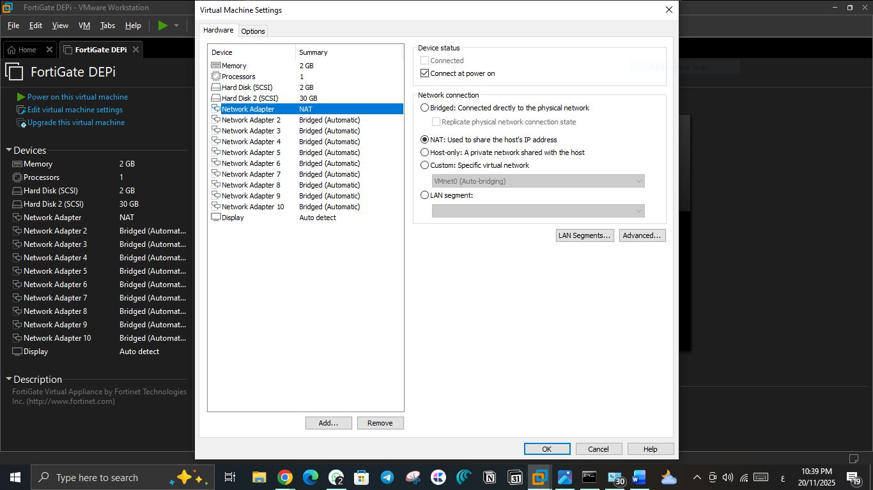
screenshot:

3. Initial Access and Network Initialization (CLI)
Objective: Access the device console to perform the initial network configuration required for GUI access.
- Step 1: System Login and Password Reset The team accessed the FortiGate console using the default factory credentials (admin / no password). Upon the first login, the system prompted for a mandatory password change to secure the administrative access. A complex password was set.
- Step 2: Configuring Management Interface (port1) To enable Graphical User Interface (GUI) access, port1 (WAN) was configured to obtain an IP address automatically via DHCP from the VMware network. Administrative access protocols (HTTP, HTTPS, PING, SSH) were enabled on this interface using the following commands:
  - config system interface
  - edit port1
  - set mode dhcp
  - set allowaccess http https ping ssh
  - end
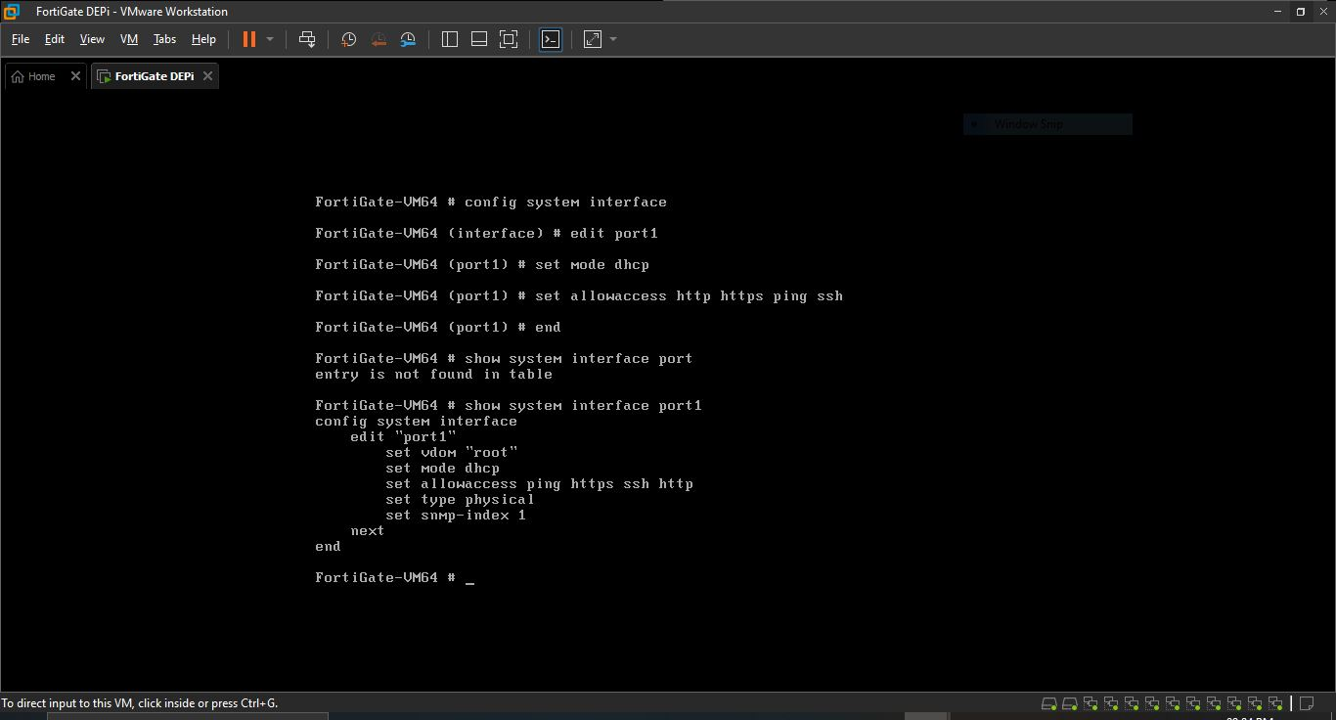
Screenshot:

- Step 3: Verifying IP Assignment The command get system interface physical was executed to verify that port1 successfully received an IP address (e.g., 192.168.136.129) and to confirm connectivity.
Screenshot:
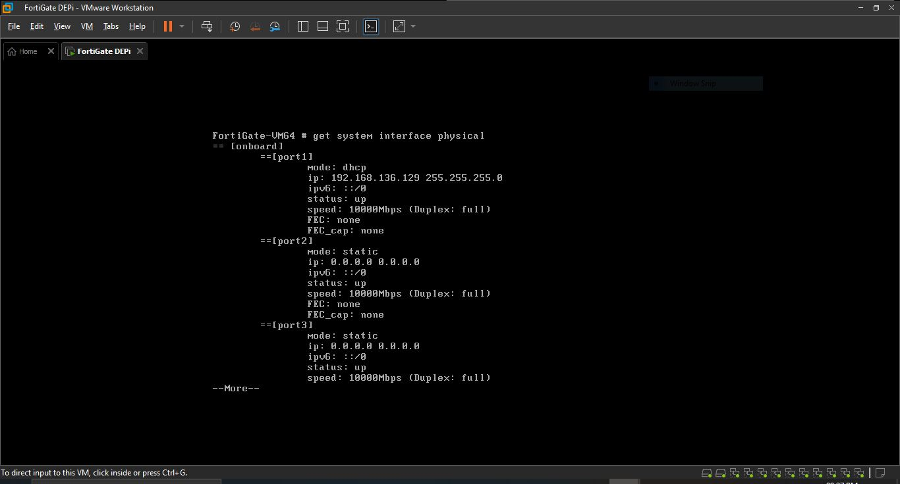

4. System Configuration
Objective: Configure device identification, time synchronization, and licensing via the GUI.
- GUI Access: Accessed the firewall via a web browser using the IP address obtained in the previous step.
- Hostname Configuration: The hostname was changed from the default serial number to DEPI-FortiGate to uniquely identify the device.
- Time Settings: The system time zone was set to (GMT+2:00) Cairo. The NTP server configuration was adjusted to use a custom server (pool.ntp.org) to resolve synchronization issues with the default FortiGuard servers.
- Licensing: The Evaluation License was successfully activated using FortiCloud credentials.

Screenshot:
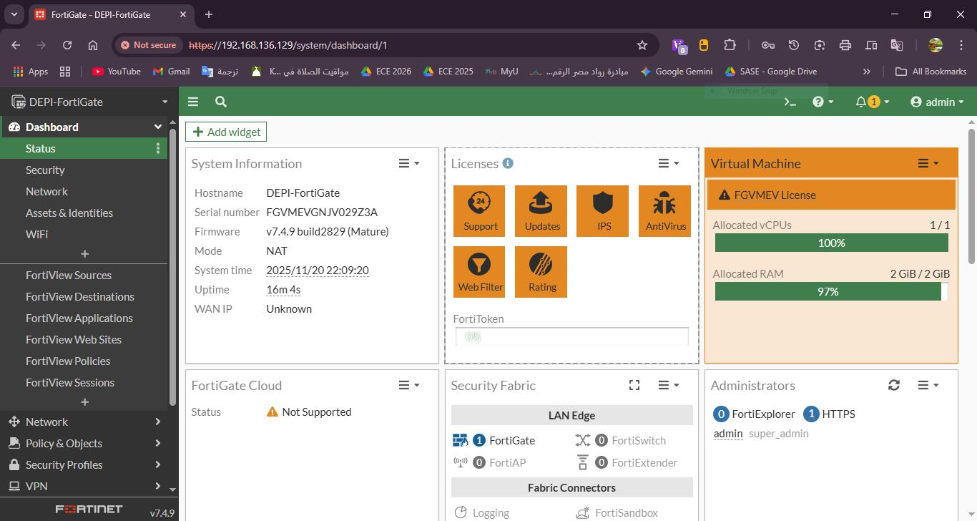

5. Network Interfaces Configuration
Objective: Configure the internal (LAN) and external (WAN) network boundaries.
- WAN Interface (port1): This interface connects to the internet. It remains configured to receive its IP dynamically (DHCP) from the ISP/VMware network.
- LAN Interface (port2): This interface was configured to serve the internal network (Employees) with the following settings:
  - Alias: Set to "LAN".
  - Role: Set to "LAN".
  - IP Address: Statically assigned as 10.10.10.1/255.255.255.0.
  - Administrative Access: Enabled "PING" for internal connectivity testing.
  - DHCP Server: Enabled to automatically assign IP addresses to internal endpoints in the range 10.10.10.2 - 10.10.10.254.

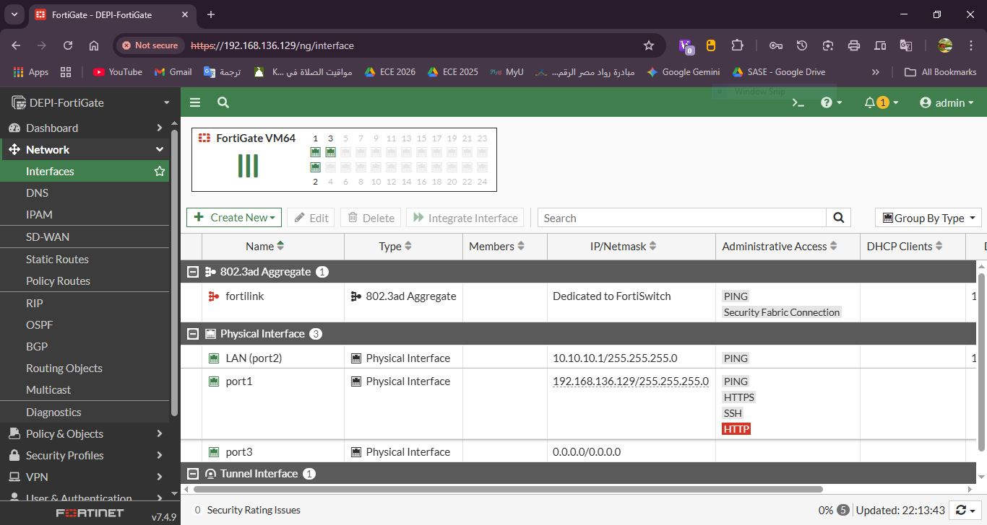
Screenshot:

6. Routing Configuration
Objective: Establish a default path for outgoing traffic to reach the internet.
- A Static Default Route was verified and configured.
- Destination: 0.0.0.0/0 (Matches all traffic).
- Gateway: 192.168.136.2 (The VMware NAT Gateway).
- Interface: port1.
- This configuration ensures that any traffic destined for the internet is correctly forwarded through the WAN interface.
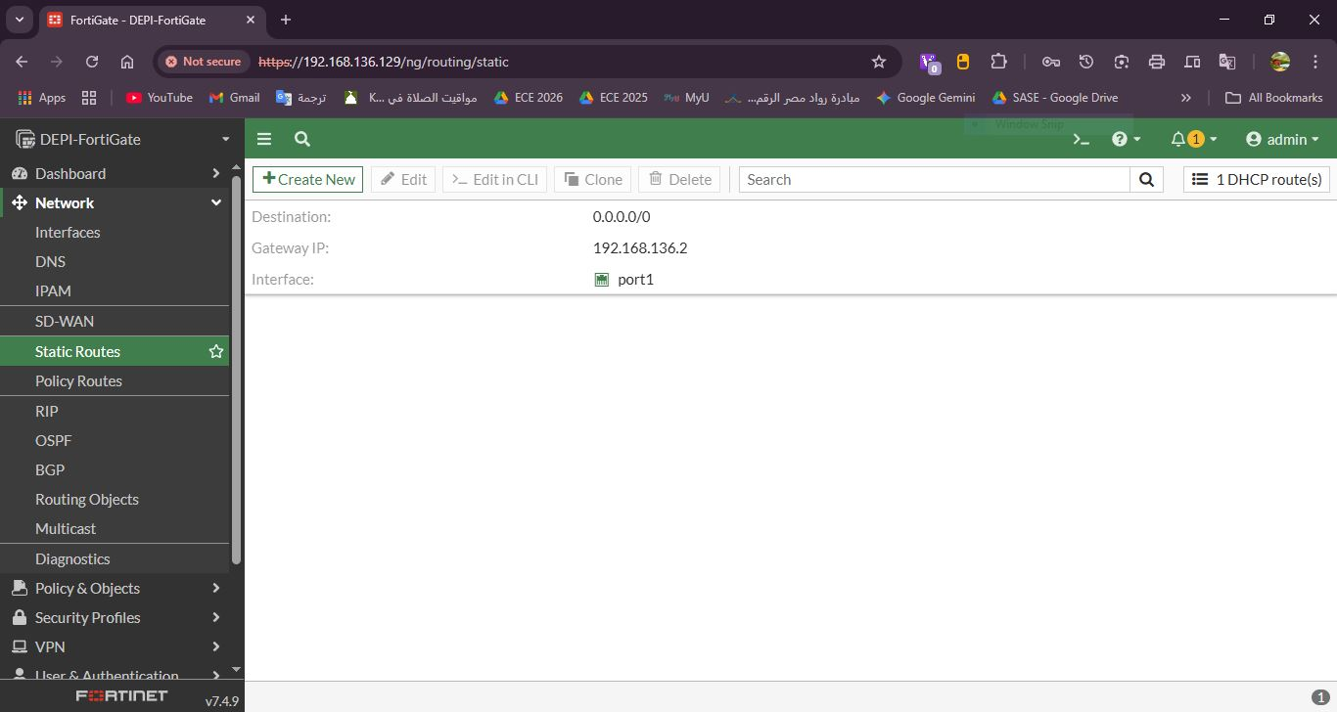
Screenshot:

7. Initial Security Policy
Objective: Enable internal users to access the internet securely.
- By default, the "Implicit Deny" policy blocks all traffic. A new firewall policy was created to permit outbound traffic.
- Policy Configuration:
  - Name: Internet-Access.
  - Incoming Interface: LAN (port2).
  - Outgoing Interface: port1 (WAN).
  - Source/Destination: All / All.
  - Action: ACCEPT.
  - NAT: Enabled (Source NAT) to translate internal private IP addresses to the firewall's external interface IP.
  - Logging: Enabled for "All Sessions" to allow for traffic monitoring and auditing.
Screenshot:
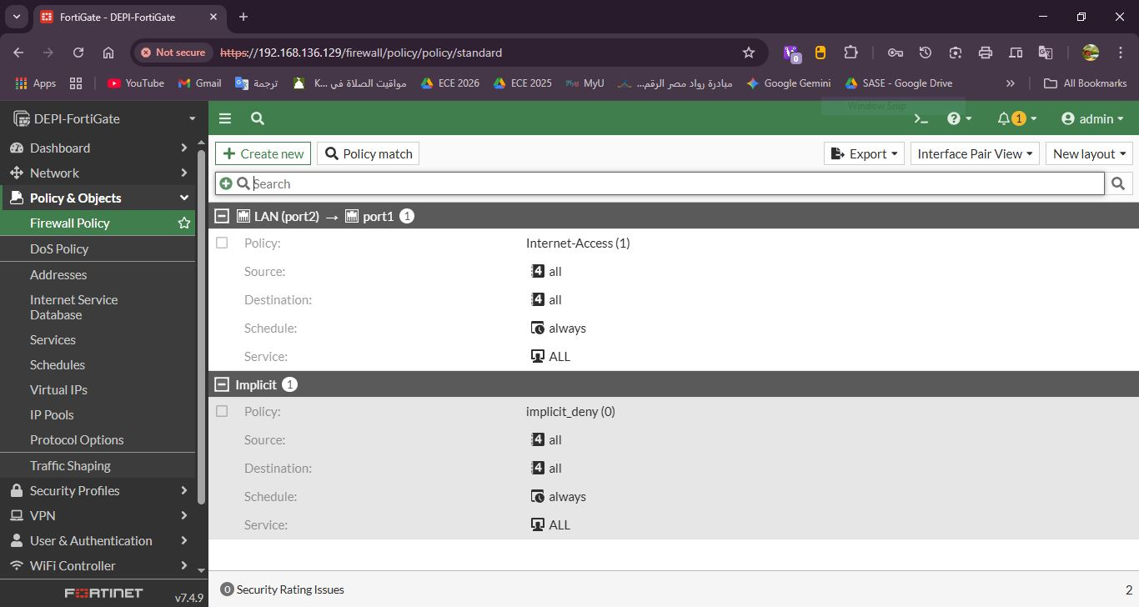

8. Conclusion
The Week 2 objectives have been fully met. The FortiGate firewall environment was successfully deployed and initialized. The network interfaces are properly segmented into LAN and WAN zones, routing is established, and the first security policy is active to allow internet connectivity. The environment is now fully prepared for advanced security configurations and NAT implementation in the upcoming phase.

